USB2.0 Removable Case kit for 3.5” HDD
U2-MDK1
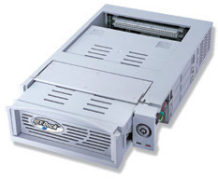
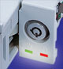
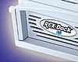


Allows HDD Exchanging
without System Shutdown or Restart.
- Allows Large Capacity (250GB)
- Plug & Play, Hot-Swappable.
- Compatible with ATA133/100/UDMA HDD,ATAPI MO/Zip.
- Best for DV Editing.
Features
- This kit includes one docking bay with USB2.0 to UDMA IDE interface module and one drive tray with mounting screws.
- The HDD can work as a hard disk mode besides a removable disk mode.
- The interface module includes RATOC's original circuit and firmware for high-performance USB2.0 to IDE conversion. It supports UDMA mode 4.
- The docking bay includes Hi-reliability 96P DIN connector, low-noise(25db-A) low power(12V/50mA) cooling fan(Air Flow 5.19CFM), and LED indicators for Power and HDD access status.
- The HDD tray includes 80-conductors ATA133/100 cable and convenient pull-out handle.
- Support Maxtor 250GB and 'Big Drive'/48bit LBA.
- Just fits in any PC tower case, external subsystem case and RAID case.
- Easy installation and usage.
- Plug and Play, recognized and mounted by the OS automatically.
- Hot-Swappable, exchangable HDD without System shutdown and restart.
- No Need for ID setting or terminators.
- Fully backward compatible with USB1.1 Host adapter and USB ports

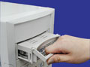
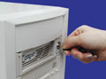
Unlock...
Allows HDD Exchanging.

System Requirements
PC with USB2.0/1.1 port
Windows XP/Me/2000/98SE

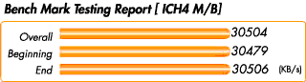
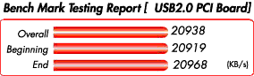
 | ICH4 M/B | USB2.0 PCI Board
PU | Intel(R) Pentium(R) 4 CPU 1500MHz | Intel(R) Pentium(R) 4 CPU 1500MHz
M/B | ASUS P4B533（845E) | FIC VC11
Memory | 256MB | 256MB
HDD | IBM Deskstar 120GXP  40GB IC35L040AVVA07-0 | Maxtor 4G160J8  (160GB 5400rpm UltraATA133)
OS | WindowsXP | Windows2000
USB2.0 port | M/B Standard(ICH4) with Microsoft driver | REX-PCIU2
Bench Mark Test Software | WinBench 99 | WinBench 99

Specifications
Features | USB2.0 Removable case kit
Interface | Upstream USB2.0 480Mbps 1 port.  Compatible with USB2.0 Spec.  Downstream IDE ATA133/100/66/33, ATAPI MO/Zip compatible.
Data transfer rate | 480Mbps/12Mbps/1.5Mbps
Power Consunption | -DC +12V/80mA (Cooling Fan) through the Power Connector  -DC +5V/250mA(Max) (Logic board) through the Power Connector  -DC +5V/300mA (Depends on HDD) through the Power Connector  -DC +12V/600mA (Depends on HDD) through the Power Connector  *Use each HDD Power cable for each U2-MDK1.
Physical Dimensions | 8.4 x 5.8 x 1.5 inches(D/W/H).  Fits in 5" half-height bay of any PC tower case, external subsystem case and RAID system case.
Weights | 490g (excluding Drive)
Package includes | -USB2.0 Removable docking bay  -HDD tray  -Mounting Screw kit  -Tray lock key set  -Cable for PCIU2U/PCIFU2U  -Cable for ICH4 M/B  -Driver and Utility software CD-ROM  - Mass storage class driver for Windows98SE.  - Hard Disk Drive/Removable Media formatting and partitioning software for WindowsMe/98SE.  - Physical formatting software.
Operating requirements | Temperature from 0 °Cto 55 °C  Relative humidity 20-80% (Non-condensing)
Installation
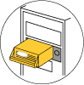
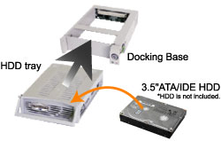

Fits to any PC tower case,
external Subsystem & RAID system cases.

U2Dock Series Products  [USB2.0 Removable Case kit  for 3.5" HDD] | Option
External 1 Bay Type  U2-DK1 | HDD Tray  FR-MR1
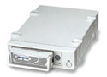 | 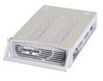
* HDD is not included.

